CANSee
2019.01.12

Technical Documentation

Table of Contents
A) Hardware 2
1) List of components 2
2) Preparing the parts 2
3) Connecting things together 3
4) Pin usage 3
B) Software 4
1) The repository 4
2) Configuration settings 4
3) Serial configuration commands 5

Hardware

List of components
- 1x ODB case with connector
https://www.aliexpress.com/item/CASE-ELM327-OBD2-Connector-J1962m-Plug-with-Enclosure-16pin-Male-Connector/32827624441.html
- 1x DOIT ESP32 DEVKIT or similar
https://www.aliexpress.com/item/ESP32S-ESP-32S-ESP32-ESP-32-CP2102-Wireless-WiFi-Bluetooth-Development-Board-Micro-USB-Dual-Core/32842731763.html
- 1x Mini DC-DC converter
https://www.aliexpress.com/item/10Pcs-Mini-DC-DC-12-24V-To-5V-3A-Step-Down-Power-Supply-1-8V-2/32848669016.html
- 2x SN65HVD230 CAN bus transceiver
https://www.aliexpress.com/item/SN65HVD230-CAN-Bus-Transceiver-Communication-Module-Thermal-Protection-Slope-Control-for-Arduino/32851150816.html
- 5x 3mm LED (blue, green, red, yellow, white)
- 4x 120 Ω resistor
- 1x 3.3 kΩ resistor

Preparing the parts
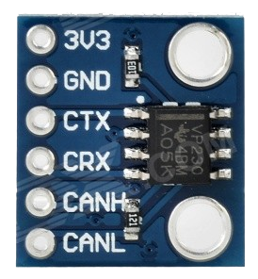
The transceivers do need some special treatment before you can use them. It has installed by default a termination resistor, which should not be there if connected to a car, so you really need to remove it or your dongle won't be able to communicate with the car.

Connecting things together
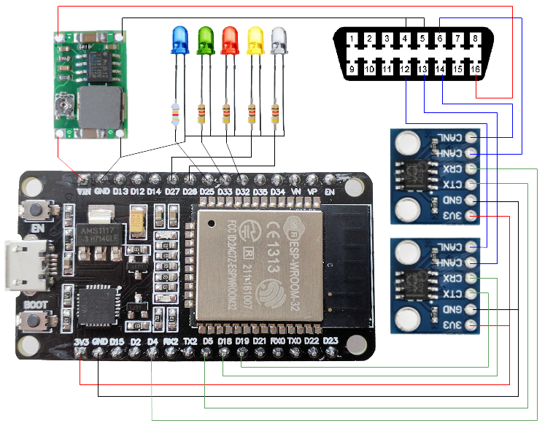
The DC-DC converter must be adjusted to an output of 5V. Don’t mix up CAN connections on the ODB2 connector, as you may break your car’s bus system if improperly connected!

Pin usage
Pin | Connection
4 | RX of main CAN bus
5 | TX of main CAN bus
18 | RX of multimedia CAN bus
19 | TX of multimedia CAN bus
25 | blue LED
26 | white LED
27 | yellow LED
32 | red LED
33 | green LED

Software

The repository
The repository of the CANSee code if located on Gitlab
https://gitlab.com/jeroenmeijer/cansee

Configuration settings
%

Serial configuration commands
Command | Explanation
a | Show all buffered free CAN_frames
z | Reboot (needed for all configuration changes except debug mode)
r | Reset configuration to default and reboot.
gxxx | Get free frame with id xxx
ixxx,yyyy | Get ISO-TP frame with id xxx, PID yyyy
nxxx,config | set EEPROM configuration  xxx is determined by this table
  100 | Set the flags configuration as hex as ssbbwwlldd [01010200ff]  ss: Serial over USB  00 for off, any other for on  bb: Bluetooth  00 for off, any other for on  ww: WiFi  00 for off, 01 for Station mode, 02 for Soft Access Point mode. For station mode a DHCP server is assumed.  ll: Use leds  00 for off, ff for on  dd: Debug  00 for off, ff for on. A bit pattern can be used and added  01: show CANbus receive free CAN_frame_std  02: show CANbus receive ISO-TP CAN_frame_std  04: show Commands issued  08: show free frame Commands  10: show ISO-TP Commands
  200 | Set the Bluetooth name [CANSee]
  201 | Set the Bluetooth pin [1234, not implemented by the API!!]
  300 | Set the WiFi ssid for Soft Access Point mode [CANSee]
  301 | Set the WiFi password for Soft Access Point mode [CANSeeMe]
  400 | Set the WiFi ssid for Station mode [Home]
  401 | Set the WiFi password for Station mode [Password]
  500 | Set CANbus parameter for CAN0 in hex as sprxtx  sp: speed in 25 kbps increments. [0x14 for can0, 0x0a for can1]  rx: Rx pin of transceiver [4 for can0, 0x12 for can1]  tx: Tx pin of transceiver [5 for can0, 0x13 for can1]  Note that this is a very advanced setting and selecting pins that are  internally used on your board (notably 6-11) will crash the board. Also  pins 34 and up are input only.
  501 | Set CANbus parameter for CAN1 in hex as sprxtx (see above).  Usage of the semi-secondary CAN bus by switching the single controller to another pin pair is not supported and basically fails spectacularly.

